If FedEx rates through ConnectShip are passing back **$0.00** values for any shipments through, check to see which client’s Shipper is affected.

For example, if Jones_Bartlet was the case, having the rates are critical since JB uses them to calculate charges to their individual customers.

The following information would be needed to fix the problem:

1) FedEx Meter # 644478

2) Account # 288569312

3) EID 261472540

4) Server – qts-wpn-apps1

Remotely log in to the **FedEx New (qts-wpn-apps1)**

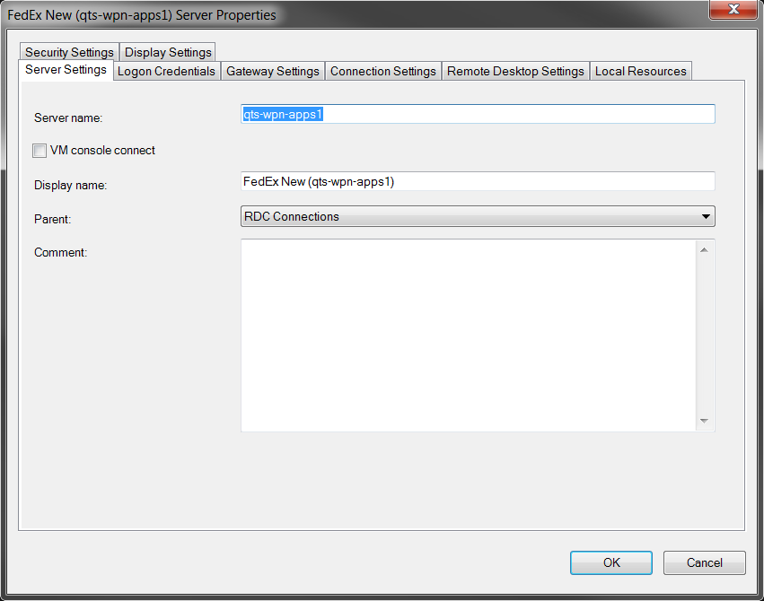

Once connected, open the **FedEx Ship Manager Server** folder near the upper-left of the desktop.

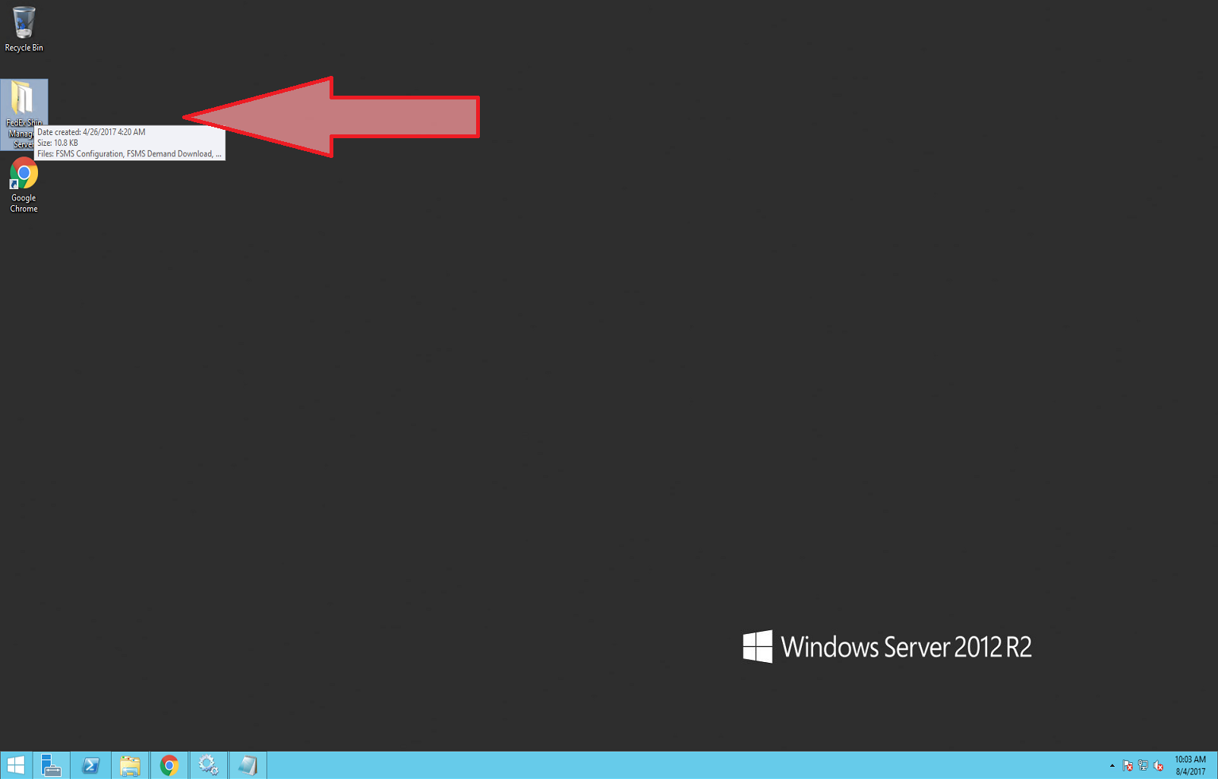

Double click on the **FMS Configuration** shortcut.

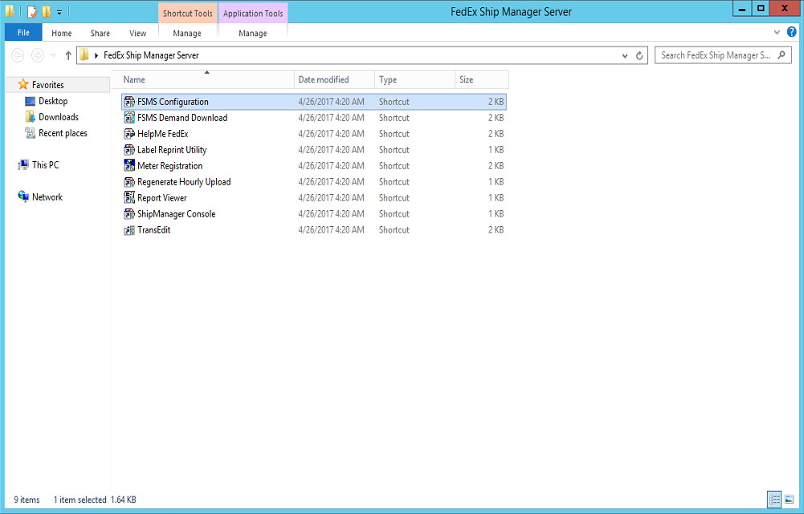

Under the **Master Meter Number** drop down box, select the appropriate meter number. In this case, 644478.

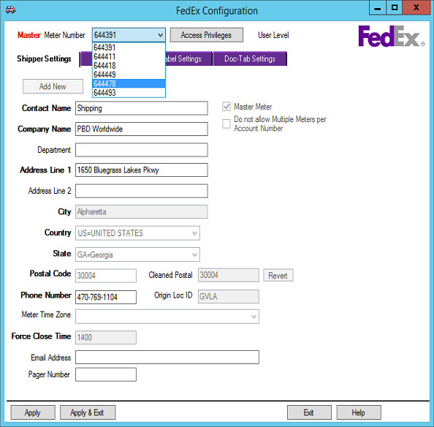

After selecting the meter number, click on the **Access Privileges** button, a dialog box requesting a password should pop up. The password is exactly as follows:

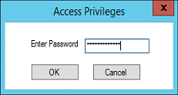

fieldpassword

Select the **Meter Settings** tab, make sure **LIST & DISCOUNT** is selected under **Express Options**. If any changes are made, make sure to click **Apply & Exit**.

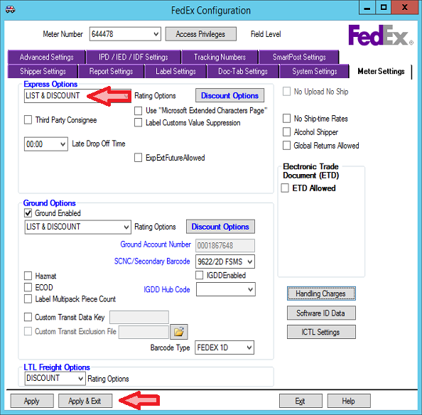

Double click on the **TrasEdit** shortcut.

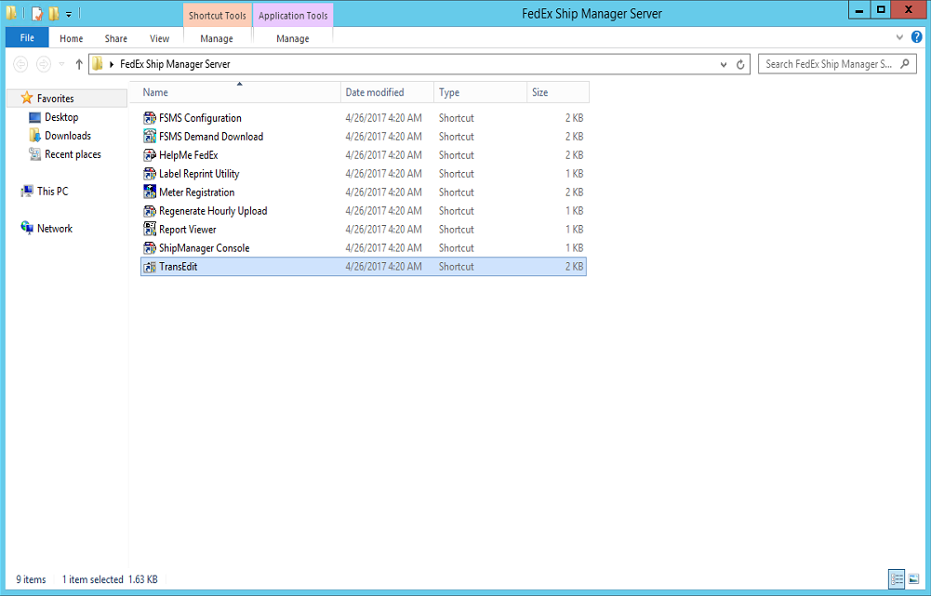

Once the **PowerShip Transaction Editor - [trans1]** is opened, click the white space shown and paste the following data shown in blue.

*0,"020"1,"TEST SHIPMENT"11,"TEST"12,"TEST"13,"123 DO NOT SHIP LANE"14,"DO NOT SHIP"15,"LOS ANGELES"16,"CA"17,"90028"18,"9015551212"23,"1"50,"US"57,"12"58,"12"59,"12"69,"100"75,"LBS"187,"PNG"537,"C:\Fedex\Fedex_LabelBuffer"570,"C:\Fedex\Fedex_LabelBuffer"1273,"01"1274,"01"1282,"S"1670,"1000"99,""*

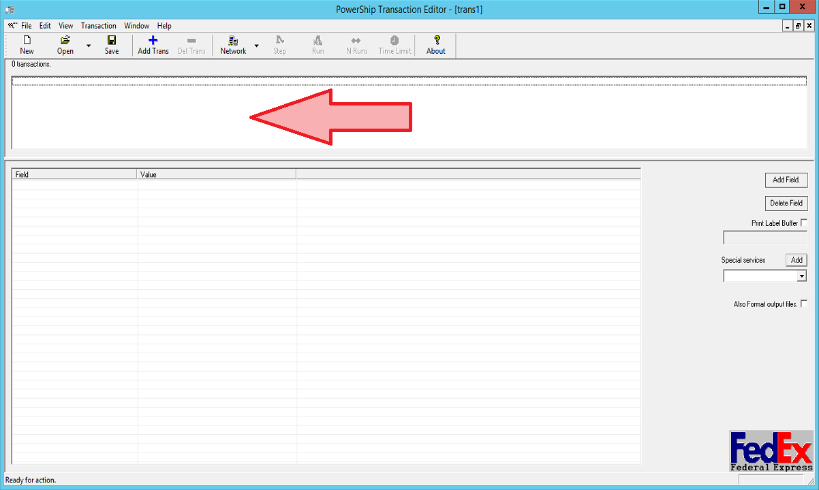

The dialog box should update like shown below:

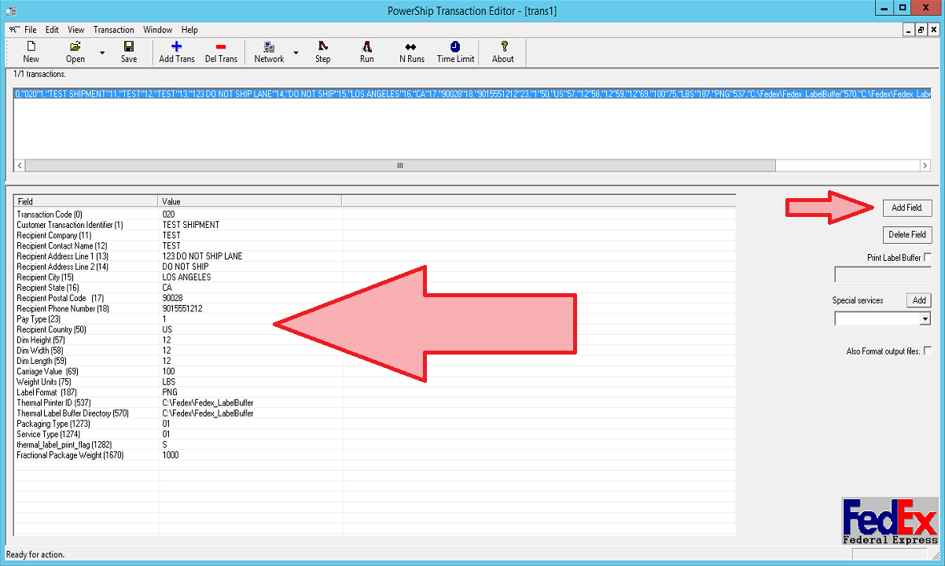

Click the **Add Field** button near the small arrow.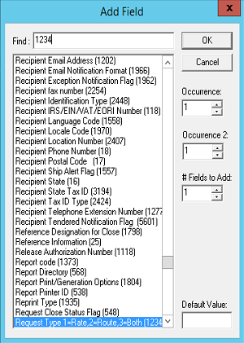

In the **Find:** text box, type ***1234*** and select the **Request Type 1=Rate,2=Route,3=Bothe(1234)** from the list.

Click the **Ok** button.

Notice the new **Field** with the empty **Value** near the big arrow, select the ***1-Rate*** from that drop down box then click **Add Field** button near the small arrow.

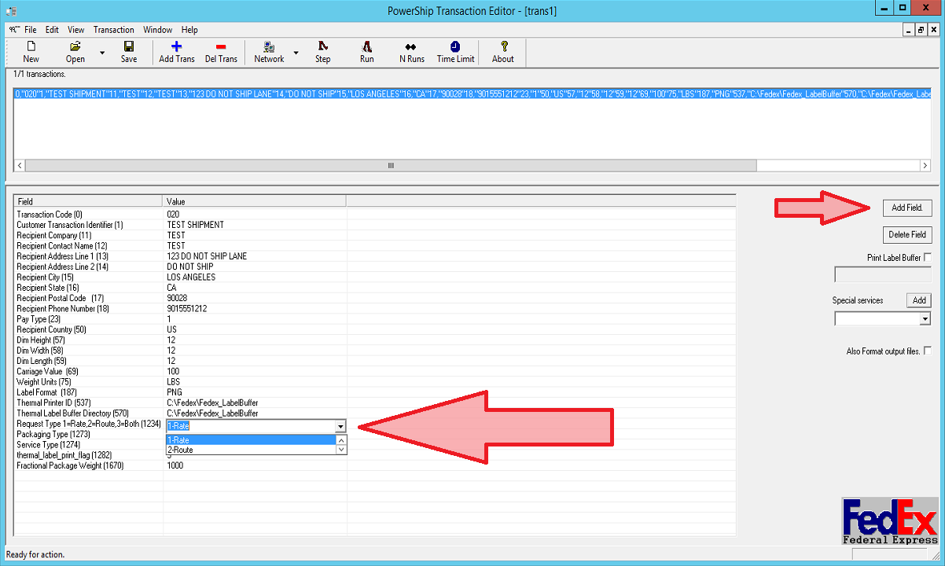

In the **Find:** text box, type ***498*** and select the **Meter Number (498)** from the list.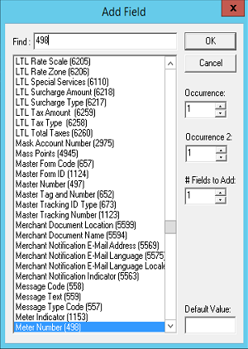

Click the **Ok** button.

Notice the new **Field** with the empty **Value** near the big arrow, type the Meter Number, in this case ***644478*** then click the **Network** button.

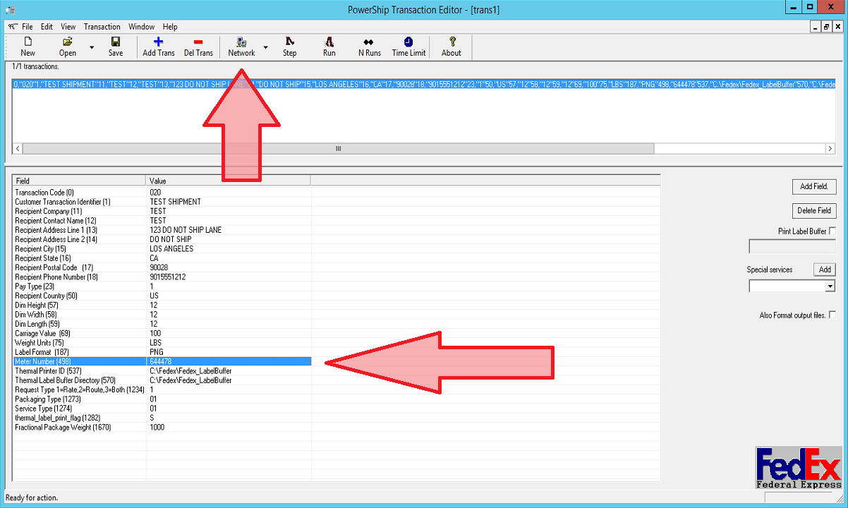

In the Network Setup, type ***127.0.0.1*** in the **Network** text box and ***2000*** in the **Port** text box then click **Ok**.

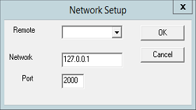

Once completed, click the **Step** button and check to verify it was fixed.

You might need to restart the **FedEx AdmnService**.

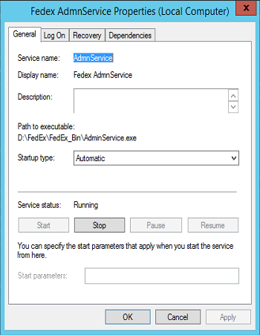

Go to **Task Manager** and find and restart the service under:

Name: **AdmnService**

Description: **Fedex AdmnService**

